Insecure Data Storage Part – 4

Open the DIVA application on android emulator

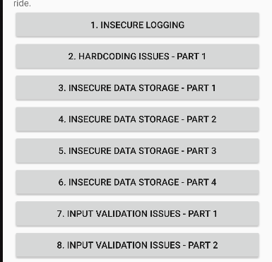

Open powershell and go to adb shel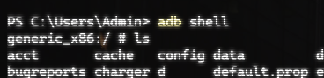l

List all the items in the shell and switch to root user using ‘su’command.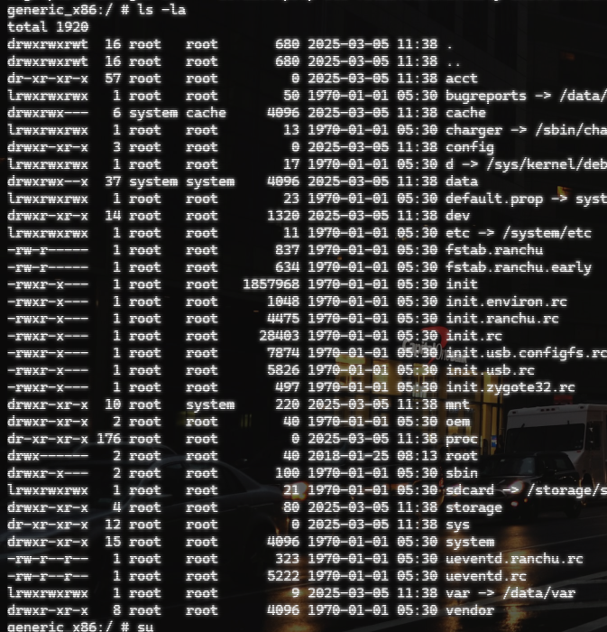

Navigate to mnt folder

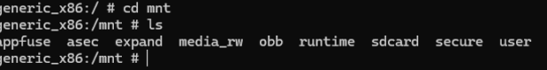

List the items in this directory

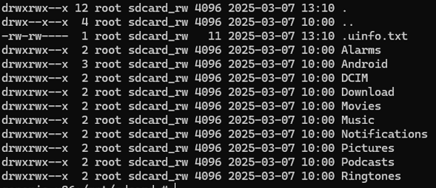

We can go back to the emulator and enter some credentials, from which we see a text file. We can view the content of this text file using ‘cat’ command to see the values that we entered before in the emulator hence exploiting the insecure data storage vulnerability.

